Shopee

Use-Case-Realization Specification: Make Payment

Version 1.0

Revision History

| **Date** | **Version** | **Description** | **Author** |
| --- | --- | --- | --- |
| 12, Dec, 2023 | <1.0> | Final | Nguyen Huyen Anh |
|  |  |  |  |
|  |  |  |  |
|  |  |  |  |

Table of Contents

1. Introduction 4

1.1 Purpose 4

1.2 Scope 4

1.3 Definitions, Acronyms, and Abbreviations 4

1.4 References 4

1.5 Overview 4

2. Flow of Events—Design 4

2.1 Sequence diagram 4

2.2 Class diagram 5

3. Derived Requirements 6

Use-Case-Realization Specification: Make Payment

# Introduction

## Purpose

The "Making Payment" use-case is a fundamental business process that allows customers to browse, select, and purchase products from an online store. This use-case encompasses the entire purchasing journey, from product selection to payment and order confirmation. The detailed specification of this use-case provides both sequence diagram and class diagram about progress of making payment to ensure clear communication and understanding among stakeholders, enabling efficient implementation and successful deployment of the e-commerce system.

## Scope

This document will describe how to purchase products in Shopee in a detailed way. This document uses MVC pattern in a sequence diagram and also supplies a class diagram.

## Definitions, Acronyms, and Abbreviations

MVC: Model-View-Controller

e-commerce: economic commerce

UML: Unified Modeling Language

## References

BMP01, version 0.1: Business Architecture Document

BMP02, version 0.1: Business Use-Case Specification: Making Payment

RD02, version 0.2: Use-Case Specification: Making Payment

## Overview

This document explains the entire purchasing journey, from product selection to payment and order confirmation of use case “Making Payment”. This has the analysis in a textual description and a thorough design by using UML (sequence diagram and class diagram). It also lists all the derived requirements for that use case.

# Flow of Events—Design

The user interacts with the system through the Payment UI. The Payment UI component displays the user's shipping and billing information, as well as their payment information through Payment Controller.

Payment Controller calculates the order total, including taxes and shipping costs. Once the order total has been calculated, the Payment Controller component places the order with the Payment UI.

When all is done, the user clicks on a Place Order button, this will redirect to Confirmed Page.

## Sequence diagram

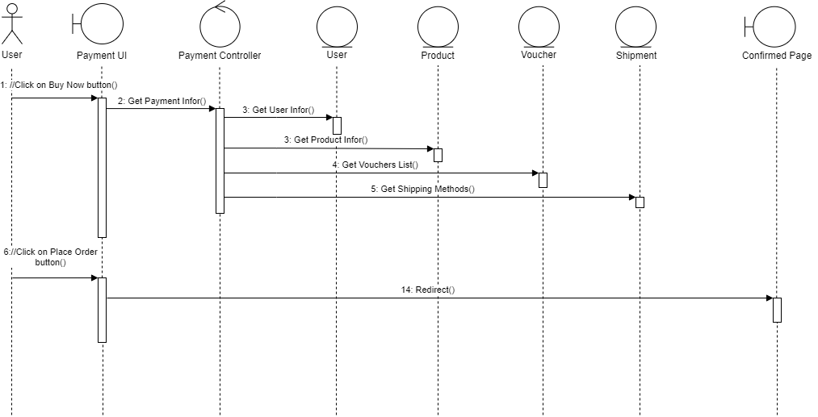

## 2.2 Class diagram

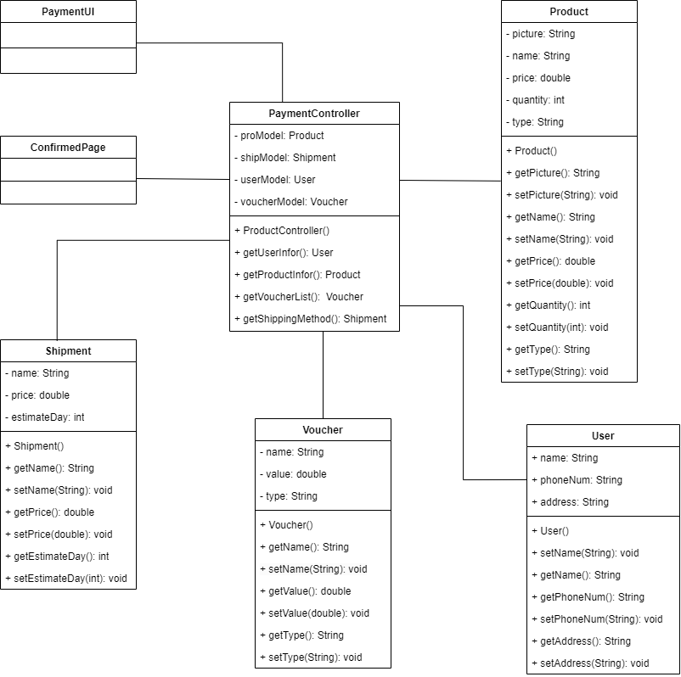

# Derived Requirements

**3.1. Response time:** The system should respond promptly to user actions, ensuring a smooth and responsive shopping experience.

**3.2. Security:**

Data Protection: Customer data, including personal information and payment details, must be protected with robust security measures to prevent unauthorized access and data breaches.

Secure Payment Processing: The payment gateway integration should adhere to industry-standard security protocols to safeguard sensitive financial information.